
Year 11 General Human Biology
Task 2: Supervised written – Cell reproduction, reproductive systems and pregnancy (10%)

RESULT
/ 37

Task 2

TYPE: Supervised Written
CONTENT: Cell reproduction, reproductive systems and pregnancy

WEIGHTING: 10%

Student Name: ____________________________
Due date: ___ / ___ / ______
Teacher: Mrs Cunningham

CONDITIONS:
Must be completed under test conditions in class. This task will be competed individually.
50 minutes allocated
37 Marks

TASK DETAILS:
This task contains four questions with a number of parts to assess the student’s understanding of the content from the science understanding topics cell reproduction, reproductive systems and pregnancy.
Notes/reference materials may not be used during this task.
This task contains a number of question types. You could be required to:
- provide single word, sentence or short paragraph responses
- provide responses making connections, drawing conclusions, constructing arguments, analysing and/or evaluating information.
Your responses may incorporate labelled diagrams or tables with explanatory notes.

Answer all questions in the spaces provided. (TOTAL 37 marks)

Question 1 (TOTAL 7 marks)

The diagram below shows the structures of deoxyribose nucleic acid (DNA).
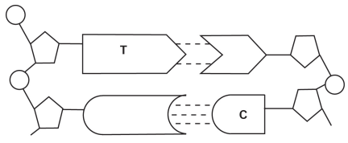

- On the diagram above, write the missing base to complete each base pair. (2 marks)

- On the diagram above, label the following structures:
- a sugar molecule (1 mark)
- a phosphate molecule (1 mark)
- hydrogen bonds. (1 mark)

- Circle the correct answer to complete the sentences below. (2 marks)

- The double helix describes the shape of

DNA chromosomes

- The region on a chromosome that contains the code for a trait an organism inherits is a

gene mitosis

Question 2 (TOTAL 11 marks)

Cell division plays a critical role in cellular growth, development and reproduction.
The diagram below shows the phases of mitosis, however, they are not in the correct order.
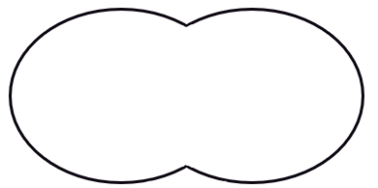
D
C
A
B
E

- List the letters A to E in the order that represents the phases of mitosis correctly. (1 mark)
______________________________________________________________________________

Sexual reproduction requires the production of gametes
- Define the term ‘gamete’. (1 mark)
______________________________________________________________________________
______________________________________________________________________________

Gametes are produced by the process of meiosis. This process produces a cell that is haploid.
- State what the term ‘haploid’ means. (1 mark)
______________________________________________________________________________
______________________________________________________________________________

Human cells contain two sex chromosomes and 22 autosomal chromosomes.
- Use the information above about humans to complete the following table. (2 marks)
Adult female
Total number of chromosomes in each body cell
Total number of chromosomes in each gamete

- Use the table below to outline three differences between mitosis and meiosis. (6 marks)
 | Mitosis | Meiosis
1
2
3

Question 3 (TOTAL 13 marks)

The diagram below shows the structure of the male reproductive system.
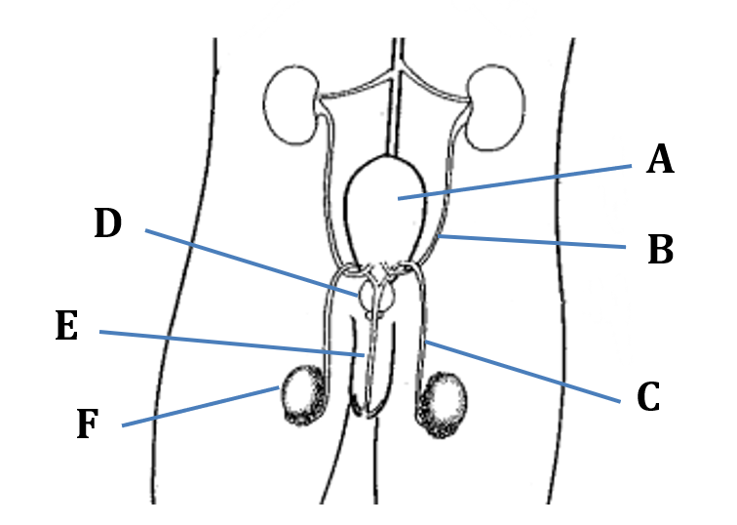
- Refer to the diagram above to complete the table below. (4 marks)
Label | Name of structure | Function of structure
A
D
 |  | Carries sperm to the urethra

Both males and females produce follicle stimulating hormone (FSH) and luteinising hormone (LH).
- Which organ is responsible for the production of these hormones? (1 mark)
__________________________________________________________________________
- Identifying the target organ or cells for each of these hormones and state their effect on the male reproductive system. Write your answers in the table below. (4 marks)
Hormone | Target organ or cells | Effect on male reproductive system
FSH
LH

Use the key below to answer the following questions (d) and (e).
2n | Total genetic material of a human cell
n | One half to the total genetic material in a human cell

- Choose which of the following representation shows correctly what happens to chromosome numbers during the process of fertilisation. (1 mark)
Option one
n
2n
2n
+

Option two
n
2n
2n
+

Option three
n
n
2n
+

Option four
4n
2n
2n
+

The correct option is: __________________________________________________________________________
- Justify your choice in question (d). (3 marks)
__________________________________________________________________________
__________________________________________________________________________
__________________________________________________________________________
__________________________________________________________________________
__________________________________________________________________________
__________________________________________________________________________

Question 4 (TOTAL 6 marks)

The following diagram is that of a pregnancy at approximately 18 weeks gestation.
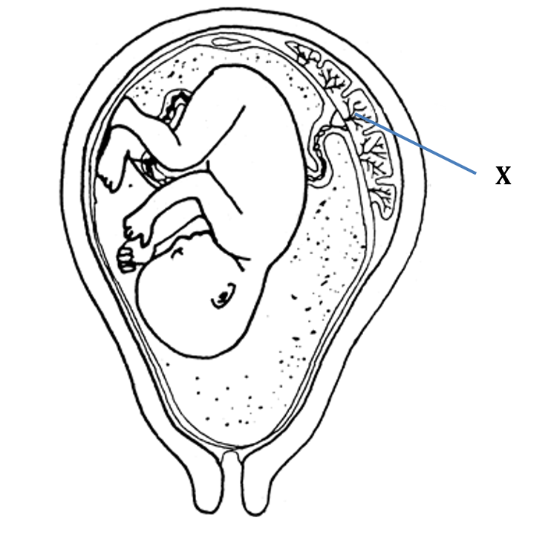
- Circle the anatomical term that best describes the baby at this stage of gestation. (1 mark)

blastocyst embryo foetus

- Identify structure X. (1 mark)
___________________________________________________________________________

- Explain how structure X is suited to the function it performs. (4 marks)
___________________________________________________________________________
___________________________________________________________________________
___________________________________________________________________________
___________________________________________________________________________
___________________________________________________________________________
___________________________________________________________________________
___________________________________________________________________________

END OF ASSESSMENT

